Outer Rim
# Source: AI Source: Provided by: [Data Path: Persons Table -> ID Column: 1, Name_En Column: Motasem Essam] -> From: [ChatGPT] on [7/25/2026]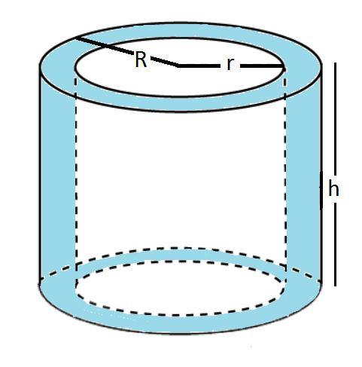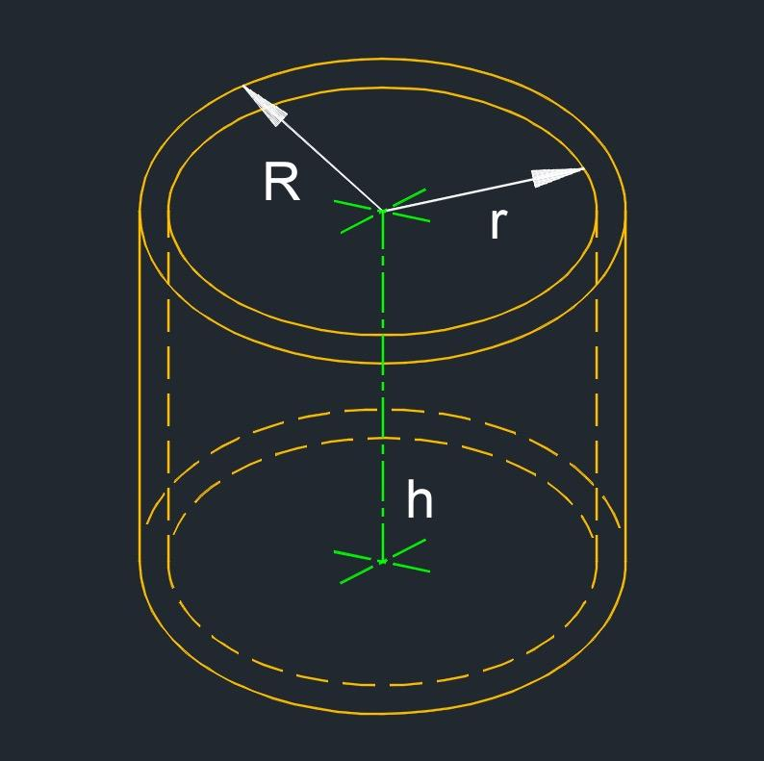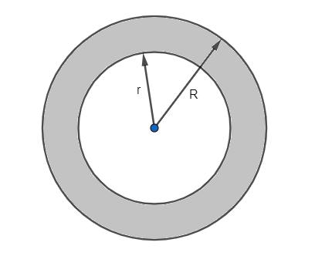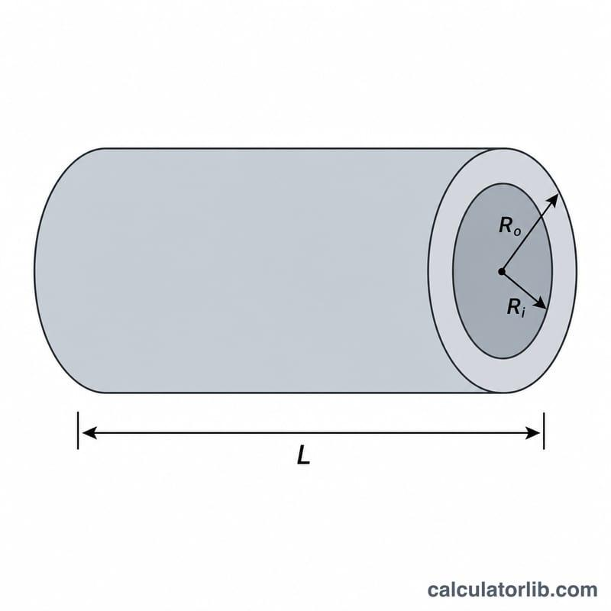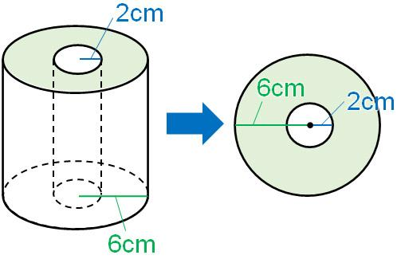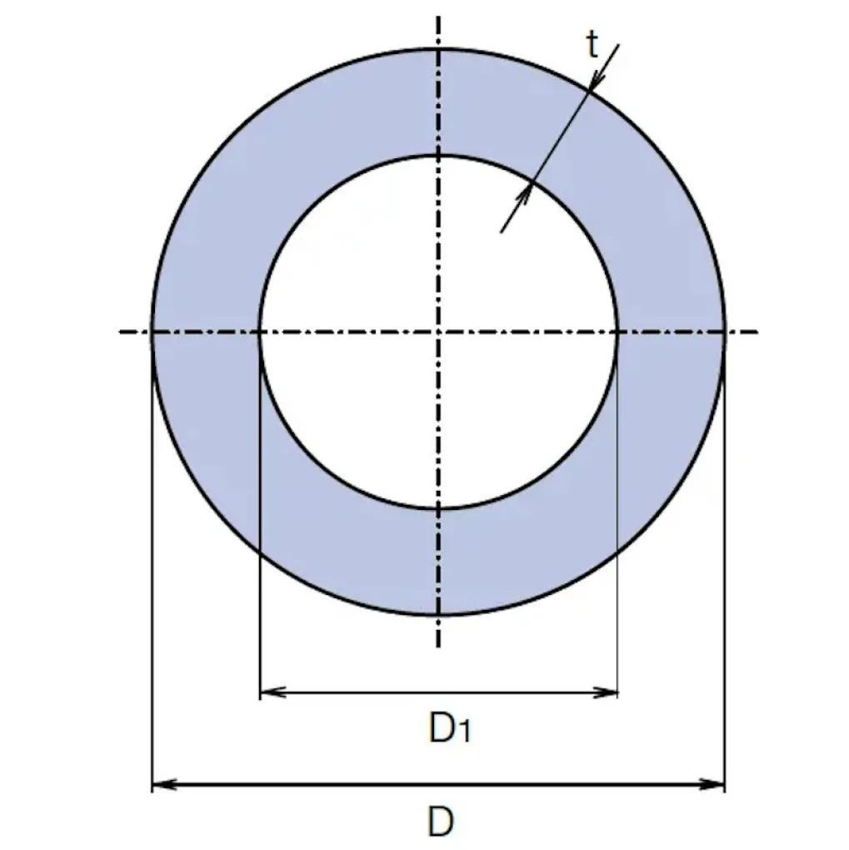

Definition
# Source: AI Source: Provided by: [Data Path: Persons Table -> ID Column: 1, Name_En Column: Motasem Essam] -> From: [ChatGPT] on [7/25/2026]
The outer rim of a hollow cylinder is the circular boundary formed where the outer cylindrical surface meets an annular end face.
A hollow cylinder typically has an outer rim at each end: one at the top and one at the bottom. Each outer rim surrounds the opening and lies at the outer radius of the cylinder.
- Position: At the outer edge of an annular end face.
- Shape: Circular.
- Outer radius: $R$.
- Outer diameter: $D_{o}=2R$.
- Circumference: $C_{o}=2πR$.
The term outer rim is especially useful for hollow cylinders, tubes, and pipes, where each end has both an outer and an inner circular boundary.

Simple Definition
# Source: AI Source: Provided by: [Data Path: Persons Table -> ID Column: 1, Name_En Column: Motasem Essam] -> From: [ChatGPT] on [7/25/2026]
The outer rim is the circular edge around the outside of a hollow cylinder's end.

Geometric Representation
# Source: AI Source: Provided by: [Data Path: Persons Table -> ID Column: 1, Name_En Column: Motasem Essam] -> From: [ChatGPT] on [7/25/2026]
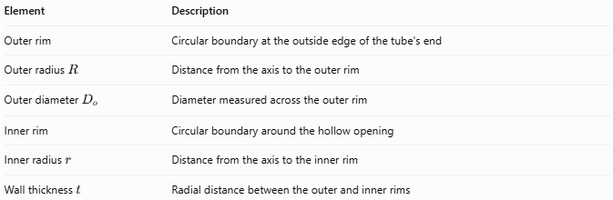
Element | Description
Outer rim | Circular boundary at the outside edge of the tube's end
Outer radius $R$ | Distance from the axis to the outer rim
$$Outerdiameter D_{o}$$ | Diameter measured across the outer rim
Inner rim | Circular boundary around the hollow opening
Inner radius $r$ | Distance from the axis to the inner rim
Wall thickness $t$ | Radial distance between the outer and inner rims
The outer rim and inner rim are concentric circles at the same end of a standard hollow circular cylinder.

Types of Outer Rims

Top Outer Rim
# Source: AI Source: Provided by: [Data Path: Persons Table -> ID Column: 1, Name_En Column: Motasem Essam] -> From: [ChatGPT] on [7/25/2026]
The outer circular boundary at the upper end of a hollow cylinder.
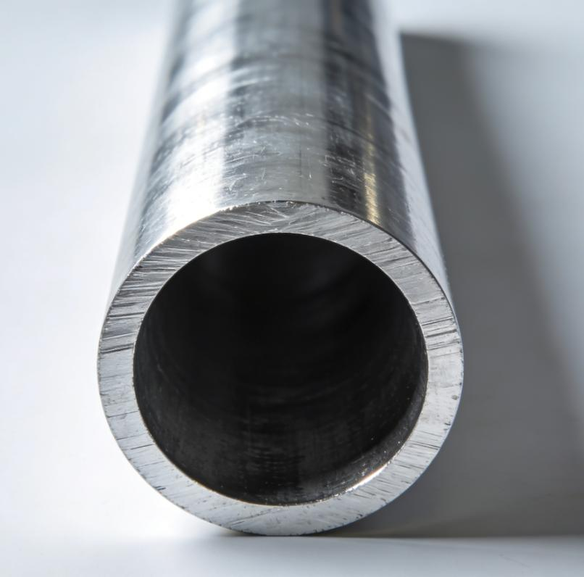

Bottom Outer Rim
# Source: AI Source: Provided by: [Data Path: Persons Table -> ID Column: 1, Name_En Column: Motasem Essam] -> From: [ChatGPT] on [7/25/2026]
The outer circular boundary at the lower end of a hollow cylinder.
For a hollow cylinder with parallel, congruent annular ends, the top and bottom outer rims have equal radii and circumferences.

Mathematical Properties and Formulas

Outer-rim circumference
# Source: AI Source: Provided by: [Data Path: Persons Table -> ID Column: 1, Name_En Column: Motasem Essam] -> From: [ChatGPT] on [7/25/2026]
The circumference of the outer rim is:
$$\boxed{C_{o}=2πR}$$
Since the outer diameter is $D_{o}=2R$:
$$\boxed{C_{o}=πD_{o}}$$

Outer radius from circumference
# Source: AI Source: Provided by: [Data Path: Persons Table -> ID Column: 1, Name_En Column: Motasem Essam] -> From: [ChatGPT] on [7/25/2026]
If the outer-rim circumference is known:
$$\boxed{R=\frac{C_{o}}{2π}}$$

Outer diameter from circumference
# Source: AI Source: Provided by: [Data Path: Persons Table -> ID Column: 1, Name_En Column: Motasem Essam] -> From: [ChatGPT] on [7/25/2026]
$$\boxed{D_{o}=\frac{C_{o}}{π}}$$

Relationship to wall thickness
# Source: AI Source: Provided by: [Data Path: Persons Table -> ID Column: 1, Name_En Column: Motasem Essam] -> From: [ChatGPT] on [7/25/2026]
For a hollow cylinder with inner radius $r$:
$$\boxed{t=R-r}$$
Therefore:
$$\boxed{R=r+t}$$
The outer rim lies at radius $R$, while the inner rim lies at radius $r$.

Annular end-face area
# Source: AI Source: Provided by: [Data Path: Persons Table -> ID Column: 1, Name_En Column: Motasem Essam] -> From: [ChatGPT] on [7/25/2026]
The outer rim forms the outer boundary of the annular end face. If the inner radius is $r$, the area enclosed between the outer and inner rims is:
$$\boxed{A=π(R^{2}-r^{2})}$$
This is the area of the end face, not the area of the outer rim itself.

Worked Examples

Example 1 — Calculate the outer-rim circumference
# Source: AI Source: Provided by: [Data Path: Persons Table -> ID Column: 1, Name_En Column: Motasem Essam] -> From: [ChatGPT] on [7/25/2026]
A hollow cylinder has an outer radius of $6 cm$. Find the circumference of its outer rim.
Solution:
$$C_{o}=2πR$$
$$C_{o}=2π(6)$$
$$\boxed{C_{o}=12π cm≈37.70 cm}$$

Example 2 — Calculate the outer radius
# Source: AI Source: Provided by: [Data Path: Persons Table -> ID Column: 1, Name_En Column: Motasem Essam] -> From: [ChatGPT] on [7/25/2026]
The outer rim of a pipe has a circumference of $30π mm$. Find its outer radius.
Solution:
$$R=\frac{C_{o}}{2π}$$
$$R=\frac{30π}{2π}$$
$$\boxed{R=15 mm}$$

Example 3 — Calculate wall thickness
# Source: AI Source: Provided by: [Data Path: Persons Table -> ID Column: 1, Name_En Column: Motasem Essam] -> From: [ChatGPT] on [7/25/2026]
A hollow cylinder has an outer diameter of $20 cm$ and an inner diameter of $14 cm$. Find its wall thickness.
Solution:
First, calculate the radii:
$$R=\frac{20}{2}=10 cm$$
$$r=\frac{14}{2}=7 cm$$
Then:
$$t=R-r=10-7$$
$$\boxed{t=3 cm}$$

Comparison with Related Concepts
# Source: AI Source: Provided by: [Data Path: Persons Table -> ID Column: 1, Name_En Column: Motasem Essam] -> From: [ChatGPT] on [7/25/2026]
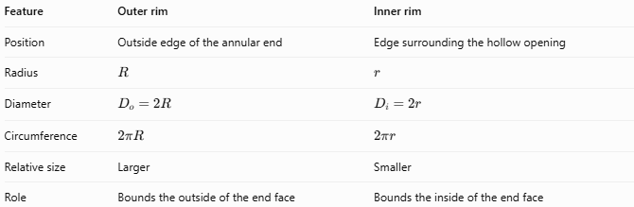
Feature | Outer rim | Inner rim
Position | Outside edge of the annular end | Edge surrounding the hollow opening
Radius | $$R$$ | $$r$$
Diameter | $$D_{o}=2R$$ | $$D_{i}=2r$$
Circumference | $$2πR$$ | $$2πr$$
Relative size | Larger | Smaller
Role | Bounds the outside of the end face | Bounds the inside of the end face
For a hollow cylinder with positive wall thickness, $R>r$, so the outer-rim circumference is greater than the inner-rim circumference.

Applications
# Source: AI Source: Provided by: [Data Path: Persons Table -> ID Column: 1, Name_En Column: Motasem Essam] -> From: [ChatGPT] on [7/25/2026]
Outer rims are useful in:
- Measuring the external boundaries of pipes and tubes.
- Designing pipe fittings and cylindrical connectors.
- Determining the outer diameter of hollow cylindrical parts.
- Calculating the annular area at the ends of tubes.
- Checking the dimensions of manufactured cylindrical components.

Key Points
# Source: AI Source: Provided by: [Data Path: Persons Table -> ID Column: 1, Name_En Column: Motasem Essam] -> From: [ChatGPT] on [7/25/2026]
- The outer rim is the circular edge where the outer cylindrical surface meets an annular end face.
- Its radius is the outer radius $R$.
- Its circumference is $C_{o}=2πR=πD_{o}$.
- A hollow cylinder normally has a top outer rim and a bottom outer rim.
- The outer rim is distinct from the inner rim and from the annular end face.
- Wall thickness is $t=R-r$.

Conclusion
# Source: AI Source: Provided by: [Data Path: Persons Table -> ID Column: 1, Name_En Column: Motasem Essam] -> From: [ChatGPT] on [7/25/2026]
The outer rim is the circular boundary along the outside edge of a hollow cylinder's end. It is defined by the outer radius and diameter and can be measured using its circumference. Together with the inner rim, it bounds the annular end face of a hollow cylinder.

